Activity

For this activity, you will create a web page template with an image map navigation. You will need some knowledge of HTML in order to complete this activity.

- Create a new folder on your student drive or computer. Name the folder Activity.

- Open your professional Bitmap & Graphic Editing Application on your student computer.

- Click on File and select New.

- From the New Document window, enter the following settings:

  - Width: 600

  - Height: 800

  - Canvas color: White

- Click OK to create the blank document.

- Select the Rounded Rectangle tool from your Toolbox.

- Use the Rounded Rectangle tool to draw a large

rounded edge rectangle onto your canvas.

- On the Properties panel at the bottom, set the fill color to #009900.

- Move to the far right side of the Properties panel and click on the Filters button. Select the Drop Shadow option. A shadow should appear behind the rounded edge rectangle.

- Select the Rounded Rectangle tool again from the Toolbox. On the properties panel, set the fill color to #CCFFFF.

- Draw a rounded rectangle inside the original rectangle. Start about ¼ of the way down so that your rectangle looks similar to the example here.

- After placing your second rectangle, center the inside rectangle horizontally.

- From the Properties panel, select a fancy font style of your choice.

- At the top of the dark green rectangle, type the heading “Premier Landscaping”. Center the heading horizontally. You should have enough space between the heading and the light green rectangle to add a navigation bar.

Creating the Navigation Bar

- From the Properties panel, select the Arial font. Set the size to 16.

- Type the menu items shown below and center them horizontally and vertically between the heading and the light green rectangle.

Home Services Care/Maintenance Contact

- From the Web section of the Toolbox, select the Rectangle Hotspot tool.

- Select an area around the word Home on your image. A light green shade should appear over the word. This shade is only a selection and will not appear on the image.

- From the Properties panel at the bottom, enter index.html in the link field and Home Page in the Alt: field.

- Select the Rectangle Hotspot tool again from the Toolbox and select the Services menu item.

- In the Properties panel at the bottom, enter services.html into the link field and Services in the Alt field.

- Select the Rectangle Hotspot tool again and select the Care/Maintenance menu item.

- In the properties panel, enter care.html into the link field and Care and Maintenance into the Alt field.

- Select the Rectangle Hotspot tool once more and select the Contact menu item.

- In the properties panel, enter contact.html into the link field and Contact Us in the Alt field.

Each of the menu items should now be shaded over, indicating that they are clickable regions on the image.

Finishing the Design

- Select the Crop tool from the Toolbox.

- Using the Crop tool, select the area around the dark green rectangle. Leave a little of the white border around the rectangle. Anything not selected will be cut away.

- Double click in the center of the selected area to cut away the excess white space around the image.

- From the File menu, select Save As…

- Save the image as pageTemplate.png to your Activity folder.

- From the Web section of the Toolbox, select the Slice tool.

- Using the Slice tool, select the inside of the light green triangle from rounded corner to rounded corner without selecting any of the dark green.

- The region you selected should appear in a darker shade of green with guidelines going out from it that indicate how the image will be sliced.

- Click on the Disc icon or press Ctrl S on your keyboard to save your design once more.

- From the File menu, select Export.

- Navigate to your Activity folder.

- Set the filename to index.html.

- The Export should be HTML and Images.

- Click on the Save button.

The image will be sliced and placed into the Activity folder. A web page will also be created that shows the image reassembled.

- From your file manager on your computer, navigate to your Activity folder. Make sure your file view settings are set to show thumbnails. You should see each of the slices, the original image, and a web page.

- Make note of the name of the section slice that you selected. In this case, it is named index_r2_c2.gif. The names are references to their location in the table on the web page (Row 2 Column 2). This is the image we want to remove from the table.

R2c2.gif

- Double click on the index.html folder to view the assembled version in your browser.

- Open index.html in your text editor.

- Locate the table cell with the image we want to remove.

- Remove the image within that cell and set the background color (bgcolor) of the cell to #ccffff. Add the v-align attribute with a value of top to the td tag. In place of the image tag that you removed, type “Content Area”.

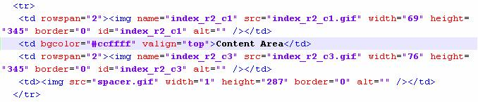

- Resave the file and refresh your browser to see an updated version of the page. Your version should look like the example shown here.

- Switch back to your text editor. From

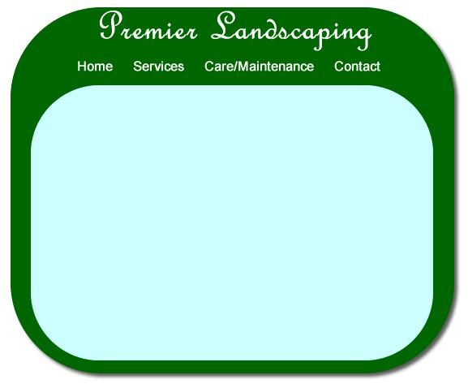
here, you can change the title of the
page or center the table on your page.

- After you have completed any additional changes, resave the file. Also, save it again under the following additional filenames:

  - services.html

  - care.html

  - contact.html

- Click on each of the links at the top of your pages and make sure they all work. If any do not work, you will need to correct the error in the HTML code.

