Design Principles Notes Organizer

- List the four design principles in the first column of the table below.

- Define each design principle in the second column of the table below.
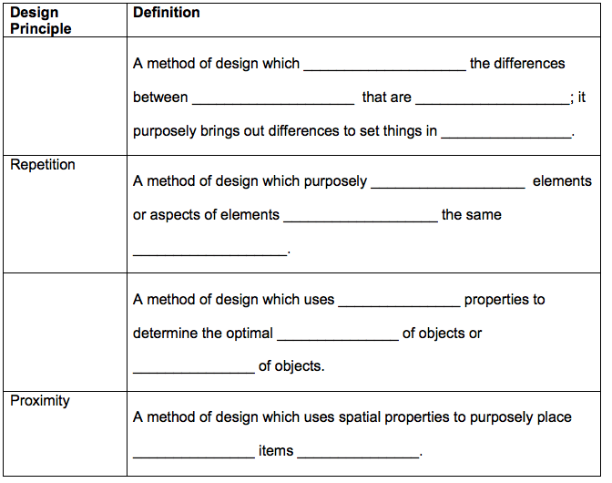

- Contrast: to be effective, it needs to be _______________. Can be demonstrated using _____________, ______________, _____________, ______________.

- Two colors that create the strongest contrast are ___________ and ___________.

- Besides color, font can be changed in these ways to create contrast:

_______________ , _______________ , _______________ .

- Repetition: items must have obvious _______________. Can be demonstrated using _______________ , _______________ , ______________________ .

- Using images for repetition: Using an exact copy of a clip art image, even

_______________ creates unity. Using different images but with a common theme is _______________.

- Alignment: Items must have obvious spatial _______________. Needs to be visually noted instantly to be effective. All items should significantly _______________ the purpose of the publication. Element placement should never be _______________.

- Alignment: Can be demonstrated using object _______________, text _______________, line spacing and object size.

- Proximity: Provides ___________________ for the viewer. All elements are supportive of main purpose. Elements are then divided into subgroups. Items related to each subtopic should be spatially grouped ___________________ in an arrangement.

- Can be demonstrated using ________________, _______________, Objects or Alignment.

