Find Me: All About the Internet KEY
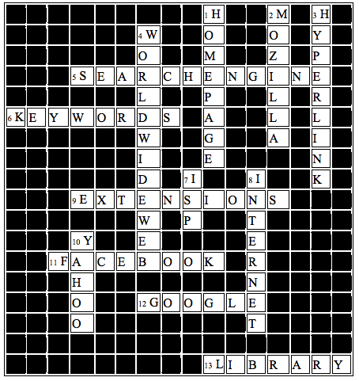

Across
- A program that searches the web for specified keywords and return hits. (2 Words)
- Type these in search engines to get information
- A suffix at the end of a URL that specifies program
- A social Network used by friends and family on the Internet
- Popular Search engine that switches its homepage on holidays
- Was used to do research before the invention of the internet
Down
- The main page of a web site. Pops up when you first start your Internet Browser.
- Newer Web Browser
- A picture or text that links to another place on the internet of document.
- WWW
- An organization or enterprise that proves access to the Internet.
- Started with ARPAnet by the Government: A collection of electronic network of computers
- A popular search engine. Name is similar to a milk drink

