Forensic Science

Hair Microscopy Handbook

Name:

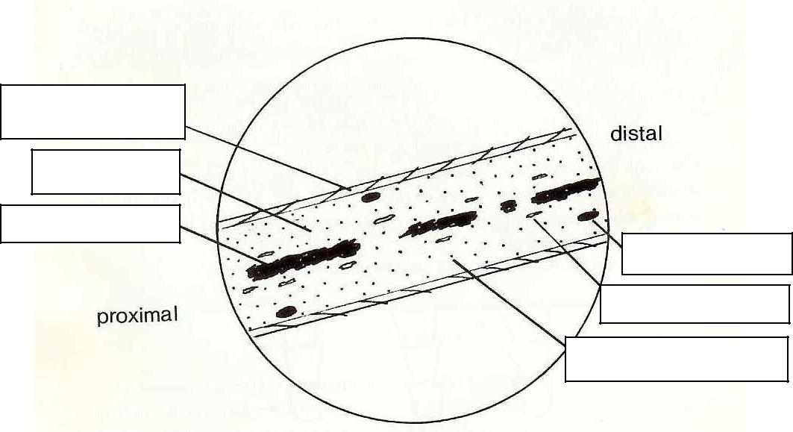
Structure of Hair

3 Stages of Growth

1) Phase

2) Phase

3) Phase

Human vs. Animal: 3 Main Differences
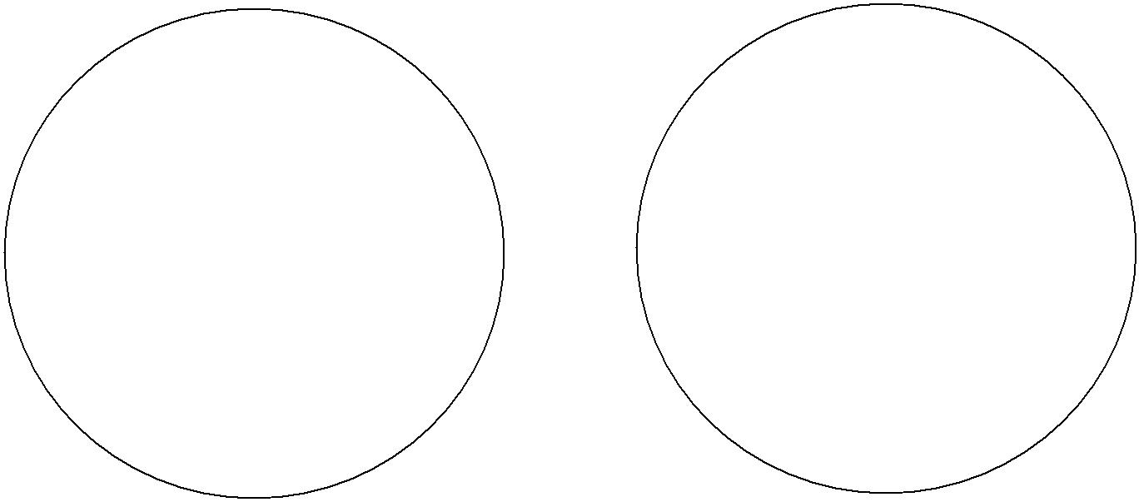

Human Animal
1)

2)

3)

3 Scale Types

4 Types of Human Medulla

- Absent

- Fragmented

- Discontinuous

- Continuous

Racial Characteristics

- Caucasian
  - Shaft diameter:

  - Pigment:

  - Cross-section shape:

  - Cuticle thickness:

  - Configuration:

- Mongoloid

  - Shaft diameter:

  - Pigment:

  - Cross-section shape:

  - Cuticle thickness:

  - Configuration:

- Negroid

  - Shaft diameter:

  - Pigment:

  - Cross-section shape:

  - Cuticle thickness:

  - Configuration:

Somatic Origin
- Head Hairs

____________________________________________________________________________________________________

____________________________________________________________________________________________________

- Pubic Hairs

____________________________________________________________________________________________________

____________________________________________________________________________________________________

- Limb Hairs

____________________________________________________________________________________________________

____________________________________________________________________________________________________

Facial Hairs
- Beard/mustache

____________________________________________________________________________________________________

____________________________________________________________________________________________________

- Eyebrow/Eyelash

____________________________________________________________________________________________________

____________________________________________________________________________________________________

Other Body Hairs
- Chest Hairs

____________________________________________________________________________________________________

____________________________________________________________________________________________________

- Auxiliary or Underarm Hairs

____________________________________________________________________________________________________

____________________________________________________________________________________________________

Hair Characterization Exercises

Slide # Human or animal?

Root:

Configuration:

Shaft Diameter:

Color:

Pigment Size & Density:

Pigment Distribution:

Medulla:

Cuticle:

Race (if human):

Somatic origin (if human):

Slide # Human or animal?

Root:

Configuration:

Shaft Diameter:

Color:

Pigment Size & Density:

Pigment Distribution:

Medulla:

Cuticle:

Race (if human):

Somatic origin (if human):

Slide # Human or animal?

Root:

Configuration:

Shaft Diameter:

Color:

Pigment Size & Density:

Pigment Distribution:

Medulla:

Cuticle:

Race (if human):

Somatic origin (if human):

Slide # Human or animal?

Root:

Configuration:

Shaft Diameter:

Color:

Pigment Size & Density:

Pigment Distribution:

Medulla:

Cuticle:

Race (if human):

Somatic origin (if human):

Slide # Human or animal?

Root:

Configuration:

Shaft Diameter:

Color:

Pigment Size & Density:

Pigment Distribution:

Medulla:

Cuticle:

Race (if human):

Somatic origin (if human):

Slide # Human or animal?

Root:

Configuration:

Shaft Diameter:

Color:

Pigment Size & Density:

Pigment Distribution:

Medulla:

Cuticle:

Race (if human):

Somatic origin (if human):

Slide # Human or animal?

Root:

Configuration:

Shaft Diameter:

Color:

Pigment Size & Density:

Pigment Distribution:

Medulla:

Cuticle:

Race (if human):

Somatic origin (if human):

Slide # Human or animal?

Root:

Configuration:

Shaft Diameter:

Color:

Pigment Size & Density:

Pigment Distribution:

Medulla:

Cuticle:

Race (if human):

Somatic origin (if human):

Slide # Human or animal?

Root:

Configuration:

Shaft Diameter:

Color:

Pigment Size & Density:

Pigment Distribution:

Medulla:

Cuticle:

Race (if human):

Somatic origin (if human):

Slide # Human or animal?

Root:

Configuration:

Shaft Diameter:

Color:

Pigment Size & Density:

Pigment Distribution:

Medulla:

Cuticle:

Race (if human):

Somatic origin (if human):

Slide # Human or animal?

Root:

Configuration:

Shaft Diameter:

Color:

Pigment Size & Density:

Pigment Distribution:

Medulla:

Cuticle:

Race (if human):

Somatic origin (if human):

Slide # Human or animal?

Root:

Configuration:

Shaft Diameter:

Color:

Pigment Size & Density:

Pigment Distribution:

Medulla:

Cuticle:

Race (if human):

Somatic origin (if human):

