Name ____________________________________________________________Period__________________________Date_______________

In-State versus Out-of-State College/University Comparison

Complete each section with information from your research.

In-State College/University | Out-of-State College/University
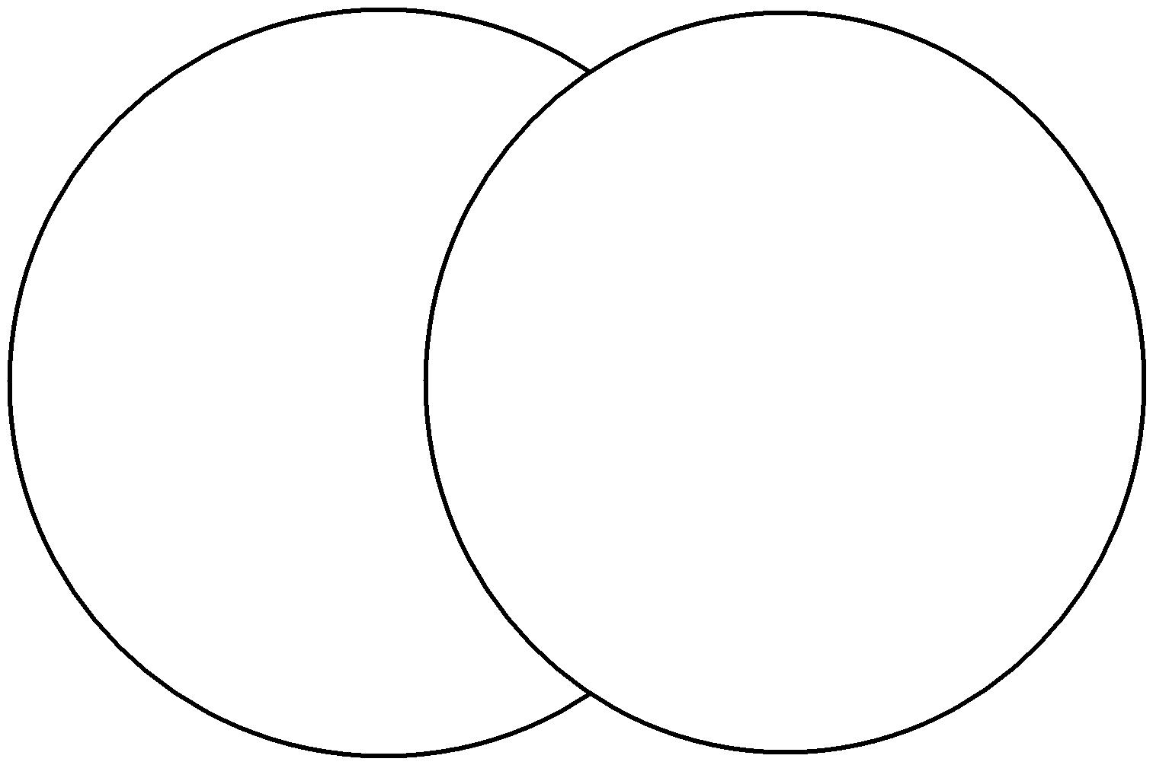

Accepted! College Selection and Admission
Copyright © Texas Education Agency, 2015. All rights reserved.

