Name______________________________Date___________________Class_____

QUIZ ANSWER KEY
Introduction to Robotics: Part 3

- The propulsion system is also called the:
  - Structural system
  - Motion system
  - Control system
  - Sensor system

- Which gear always goes in the numerator of a gear ratio calculation?
  - The driving gear
  - The driven gear
  - Either, it doesn’t matter
  - Neither, this is not the way you calculate gear ratio

- The gear ratio of 2 gears with the same pitch is the same as:
  - The ratio of the diameters
  - The ratio of the number of gear teeth
  - The ratio of the circumferences
  - All of the above

- Which device converts electrical energy into mechanical energy?
  - Generator
  - Battery
  - Light bulb
  - Motor

- How do we control the speed of a DC motor?
  - By changing the wires
  - By converting from DC to AC
  - By changing the amount of DC voltage
  - You cannot control the speed of a DC motor

- What is the relationship between DC motor speed and DC motor current?
  - They are inversely related
  - They are directly related
  - It depends on the gear ratio
  - There is no relationship between DC motor speed and DC motor current

- What symbol do we use for angular velocity?
  - Ω
  - ω
  - ϕ
  - τ

- What term is common for angular velocity in America?
  - RPM
  - MPH
  - MPG
  - Radians per second

- Which of the following gets electricity into the rotor?
  - Axle
  - Stator
  - Commutator
  - Brushes

- Which of the following switches voltage polarity during rotation?
  - Axle
  - Stator
  - Commutator
  - Brushes

- Which of the following connects the motor to the external load?
  - Axle
  - Stator
  - Commutator
  - Brushes

- What symbol is used for torque?
  - Ω
  - ω
  - ϕ
  - τ

- CEMF is directly proportional to:
  - Current
  - Torque
  - Angular velocity
  - Terminal resistance

Given the following characteristics for a motor: (all values are at 7.2 V)
Free Speed: 43 RPM
Stall Torque: 24 in·lbs
Stall Current: 3.34 amps
Free Current: 0.32 amps

- What is the terminal resistance for this motor?

- What is the constant of proportionality (k_{e}) for the motor in question 14?

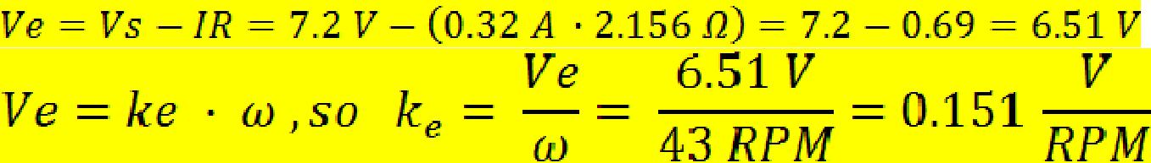

- If the load applied to the motor in question 14 is 10 in-lb, what is the speed of this motor?

= 25.08 RMP

- What current would this motor draw at the speed calculated in question 16?

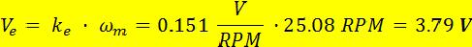

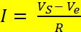 = 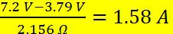

- What is the optimal speed of the motor in question 16?

Half of 43 RPM, or 21.5 RPM

- What makes this speed the optimal speed?

The torque applied to the motor will be exactly one half stall torque

- What would you have to do to get this motor to its optimal speed?

Add a gear train with a gear ratio of 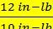 or 1.2, meaning a gear with 10 teeth driving a gear with 12 teeth

- Describe 3 things gears are used for.

To change a speed of rotation, to change a torque, to change the direction of motion of the torque

- Describe 2 things that happen to a DC motor when physical load (like the weight of a robot) increases.

Motor speed decreases, motor current increases
- Describe why you get generator action in a motor.

Because you have a conductor moving through a magnetic field, which are the conditions necessary for electrical generation.

- Draw a plot of speed vs. torque for a DC motor.
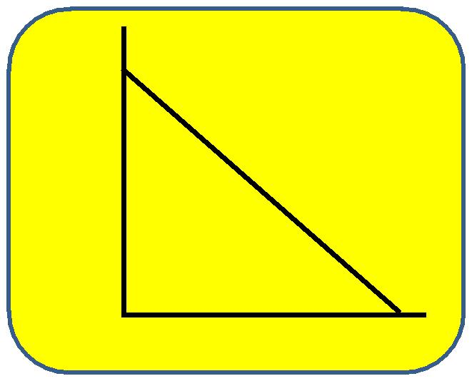

- Draw a plot of current vs. torque for a DC motor.

